**ELECTRICAL, OPTICAL AND STRUCTURAL STUDIES IN BISMUTH, ANTIMONY, BISMUTH OXIDE AND ANTIMONY OXIDE THIN FILMS**

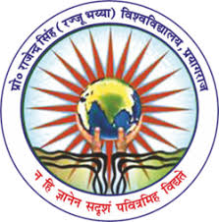

**PROF.RAJENDRA SINGH (RAJJU BHAIYA UNIVERSITY), PRAYAGRAJ**

**HEMWATI NANDAN BAHUGUNA GOVT PG COLLEGE NAINI PRAYAGRAJ**

**DISSERATION SUBMITTED FOR AWARD OF**

**MASTER OF SCIENCE**

**IN PHYSICE**

**2024-2025**

**UNDER THE SUPERVISION OF SUBMITTED BY**

**DR. HARGOVIND CHAURASIYA SUMIT GUPAT M.SC (IV Semester) Roll No:-2412495921010**

**DEPARTMENT OF PHYSICS**

**IN PARTIAL FULFILLAMENT OF THE REQUIREMENT FOR THE DEGREE OF MASTER OF SCIENCE IN PHYSICS**